By,

Md. SakibHasan(2013331508)

Md. MerazurRahman(2013331506)

This Checker Game is our 4thyear 1st semester CSE-702(Artificial Intelligence) project. This is a very common game. Our game is a complete game. What we have intended to has been completed though there are some scopes where future implementation can be performed.

We have developed the game using Unity game engine version personal 2017.1. Now, if you want to run the project you have to install the same version of unity as ours. From unity’s official website you can download the desired version of Unity.

After installing Unity if you open the engine you will find an interface like this.

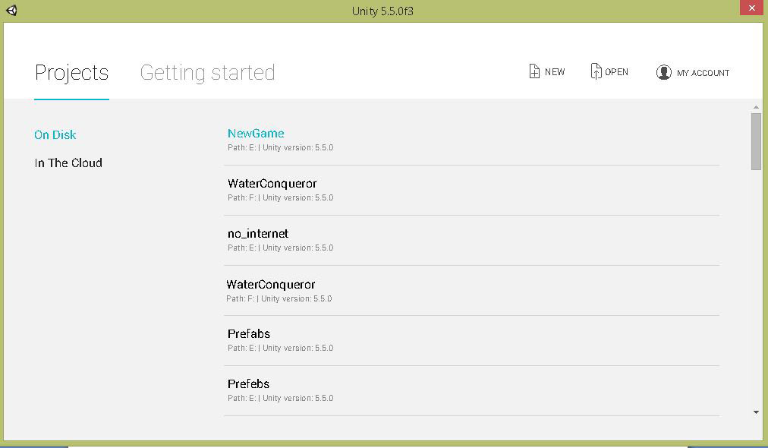

If you want to open our project click the open button showing in the upper right corner of the image we just provided. Then select the folder named “Checkers” in the CSE-702 folder and click open.

Then you can run our project. If you want to go through the project this setup is enough but if you want to generate apk then you must install android sdk and give the path for sdk in unity.

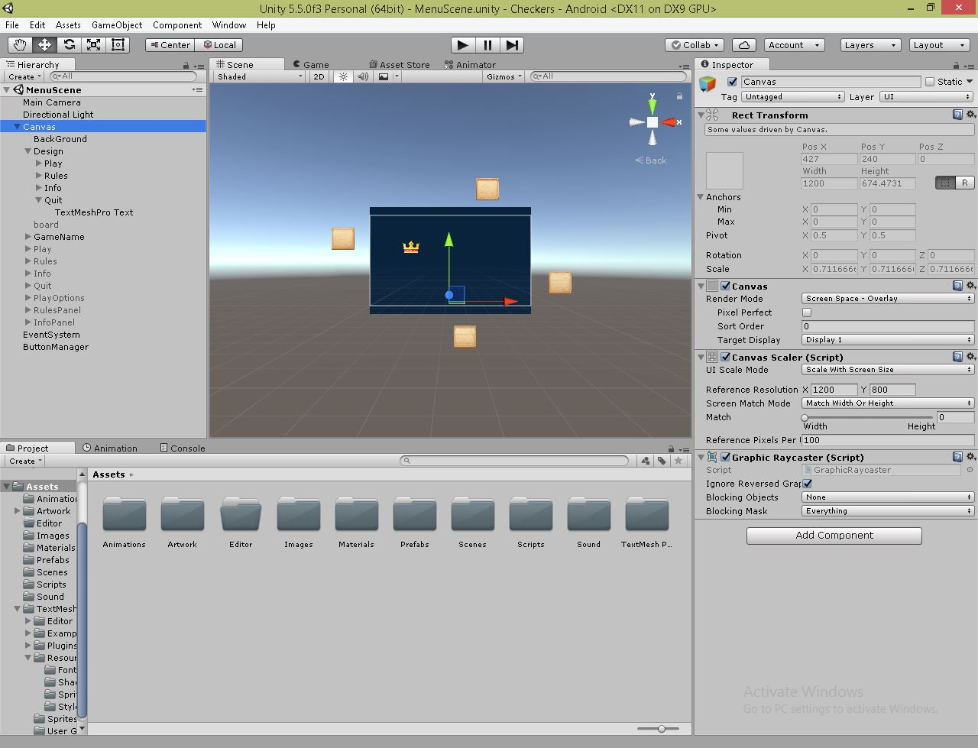

After opening the project the unity interface will be like this image given above. All the codes are in script folder residing in the assets folder in unity. We implement our code in C#.